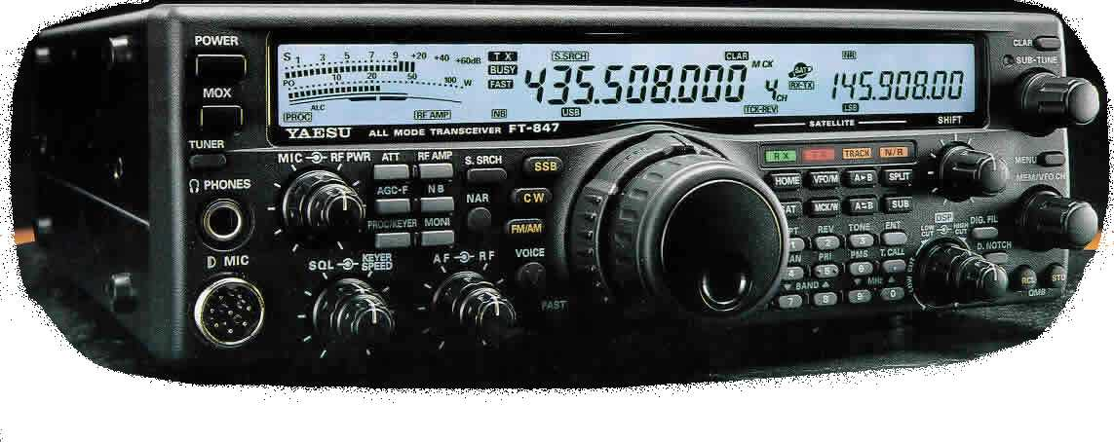
HAMRadio special print:
FT847-SuperControl® V.2.4
CAT software for the YAESU™ FT-847® amateur radio transceiver

FT847-SuperControl® is a CAT control software especifically developed for the YAESU™ FT-847® transceiver. Because of this fact, it was possible to use all the specific commands and behaviour of this unique transceiver. So we were able to produce a software, which is unique in the CAT control software market. Functions of the transceiver were improved and were equipped with tremendous additional features. The design and the overall view have been built for easy and fast control possibilities. All the important commands are visible at the same time. What makes FT847 -SuperControl® so unique in the CAT software market? Here is a general overview:
Full transceiver control via buttons in the software. Frequency, mode and other important information will be displayed in the software. |  | Programmable calculated target frequencies on two additional real time software VFO-display’s, for the use with up to four optional transverter-devices. The software is capable to administrate up to four transverter-devices (for each antenna-jack). Of course the final transverter frequencies can be used for Doppler shift calculation in Satellite-mode. |  | Wave recording of QSOs or other important signals. FT847-SuperControl® has the possibility to record signals either when the squelch has been opened or on other selectable events. For this feature, a standard audio-device in the computer is necessary. The recorded audio data can be saved automatically to a special folder to the hard drive (HDD) and can be replayed at any time.
Full support for the W4RT “OTT-847” interface, to drive LDG tuners. (AT-11MP, RT-11, A-1000, etc.). FT847-SuperControl offers One-Touch Tune and No-Touch Tune.
Open memory database with an unlimited amount of possible memories in an overall view. The memory banks of all amateur radio bands are visible and useable with ease at the same time. Several additional memory banks are available. Also memory banks with the possibility to save offset, DCS, DEC, ENC and AZ-EL data are available. The AZ-EL data can be used to drive EasyComm-compatible hardware like rotators and much more, or can be used to drive the ARS rotator interface from EA4TX. |  | Memory Scanner - Scanning of single memory banks, there is no need to scan all memory banks at the same time. Your FT-847 transceiver has only 100 internal memories, which must be scanned all at once. If you’ve saved frequencies out of different bands and if you want to scan these memories, you‘ll hear a rapid clicking of relay-type-devices in the transceiver. It is not proved, but we’re sure, that continuous long time period scanning will shorten the life of these relays type devices. This part has a skip function for memories not to be scanned, but needed to stay in memory bank. |  | DDE-interface (Dynamic Data Exchange) to satellite-tracking programs (NOVA®, SatScape etc.) for Doppler-correction in SAT- mode. The Doppler-corrected frequency can be send to the transceiver, so no manual tuning is needed anymore, when working satellites. RX- and TX-VFO will be continuously updated with Doppler-corrected data. Of course, possible calculated transverter frequencies will be taken as source for the calculation of the Doppler shift. So this part is 100% compatible with AO-40 or other super-high frequency satellites as will be future satellites.
Voice announcements of frequency, mode and other important functions.  (user definable) |  | Original like copy of the meter bars (s-meter, power-meter, discriminator-meter, etc.). Additional digital s-meter reading. |  | Clone data memory-management for the internal memories of the FT-847® transceiver. FT847-SuperControl® is able to read, edit, archive and send back clone files to the transceiver. It’s easy to set up different clone files and copy them to your hard drive. If you want to use special setups in the transceiver, simply send the wanted clone file to the rig. Clone files can be edited with the help of existing FT847-SuperControl® memory banks of course.
Voice machine (voice keyer) for contests or normal operation. |  | DTMF tone encoder and decoder.  Dual tone encoder / generator.
Automatic 10 minute station id (up to four ID’s or call signs can be recorded and used at any time). |  | Support for up to eight different serial ports. These ports are to be used when converting USB ports to serial ports.
Visual band scope with great graphics, different scan-steps and various possibilities. |  | *REAL* TCP-IP remote control in local area networks (LAN) or also via the internet (WAN). Password security, Log! |  | Full duplex cross band repeater with semi repeater-offset. The FT-847 itself will do one-way cross banding only.
Configurable home channels for each amateur radio band. |  | Priority channel supervision (you can use up to eight priority-channels at the same time!) |  | Full featured VFO scanner with software based quick memory bank - function QMB). It’s possible to set up different scan ranges.
Logbook-/ Skedbook function. |  | Software- / Keyboard CW-Keyer |  | AF Spectrum scope (Audio frequency).
Internet based telnet DX-cluster function shows the latest DX-spots in the VFO-display of the software. |  | It is possible to use the Yaesu FC-20 automatic antenna tuner at the same time with the CAT-interface! |  | ARS – It’s possible to set up different automatic repeater shift offsets in the same band.
Support for the ARS- and EasyComm interface to drive compatible optional hardware like rotor interfaces, etc. |  | The local- and the UTC-time and date display can be configured for any country. |  | Testing environment for undocumented CAT-commands.

Copyright © 2004 by Peter R. Pfisterer DH1NGP-JA1OLB, all rights reserved - http://www.supercontrol.de

