Transceiver becomes a blackbox
CAT- control for the FT-847

Satellite operation as a special feature
New satellites conquer the orbit, while everybody talks about satellite AO-40.
This satellite can only be used with the use of special equipment like transverter or down-converter devices. If you have a transverter device, you can turn on the on-screen frequency translation, which will show you the final frequency in a new VFO display in the software. FT847-SuperControl supports up to four transverter devices at the same time. Of course the final frequencies in the additional VFO’s can be used to calculate the correct Doppler shift with the help of satellite tracking programs. With the DDE-interface in FT847-SuperControl, there is a possibility to connect to satellite tracking programs like NOVA© [2] or SatScape© [3], to be able to get the actual satellite data which is needed to calculate the real Doppler shift from. The calculated Doppler shift can be send to the transceiver automatically, so a manual tuning of the transceiver's RX- and TX-frequency is no longer needed. FT847-SuperControl is able to tune the transceivers frequency according to the changes of the Doppler shift.

Additional features
Your FT-847 transceiver can be controlled directly by the computer via a graphical user interface (GUI). Also remote control via networks is possible. Frequency, mode, meter displays and much more will be continuously polled from the transceiver, so changes on the transceiver itself will be recognized by the software. You can immediately watch the changes in the software.

These functions and many more features can be evaluated in the available demo version of FT847-SuperControl [1].

Peter Pfisterer, DH1NGP (Developer)

Bibliographical data and web links:
[1] FT847-SuperControl free demo version available for download :
e-mail: info@supercontrol.de
web: www.supercontrol.de,
[2] NOVA® free demo version available for download :
web: www.nlsa.com/
[3] SatScape® free full version:
web: www.satscape.co.uk
[4] German distribution :
WiMo Antenna and Electronic Ltd.
Am Gaexwald 14, 76863 Herxheim
Phone: (+49) 07276 – 96680
e-mail: info@wimo.com
web: www.wimo.com

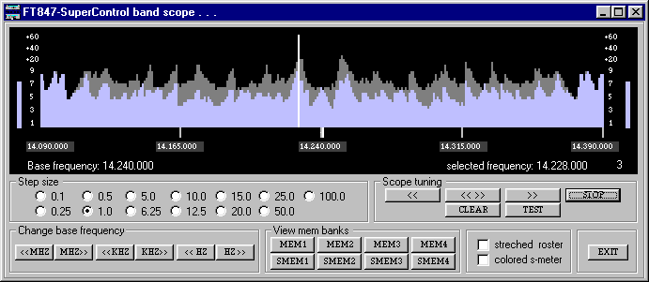
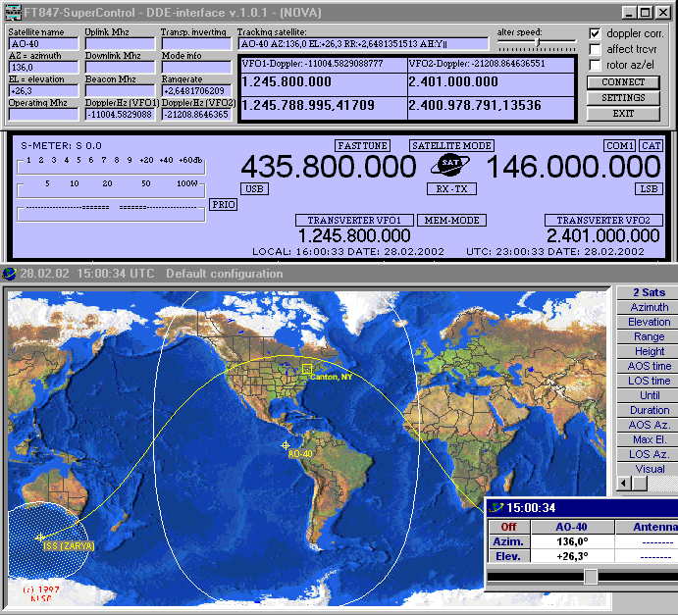

Peter Pfisterer, DH1NGP
Place the transceiver away from you and select all the important functions and things from the computer – only the communication itself must be done by yourself. The serial CAT interface will make it possible. “SuperControl” will take care of all the functions.

Most of the manufacturers of amateur radio transceivers will have an eye on everything what is useful in their new developments. They try to implement functions which makes operators live easier. But sometimes they forget to add important things, also if they would be easy to implement at the design stage.
Compared with the normal functions, which can be used also from the transceiver itself, FT847-SuperControl offers additional and improved functions. FT847-SuperControl is a CAT control software which is especially developed for the YAESU™ FT-847® transceiver. Due to that fact it was possible to use special details of the transceiver. For example you can find an internal function which is used to turn the FT-847 transceiver into a crossband repeater. Unfortunately this function is only an internal one-way crossband repeater. FT847-SuperControl will extend this function by switching both VFO’s continuously, so you can transmit and receive on both VFO’s like on a normal full duplex crossband repeater. You also can set up a repeater offset to one VFO while crossbanding. So it will be possible to access normal repeaters via the full duplex crossband repeater function! If you have a repeater at your location, on which the carrier falls off fast, you can try to work it via the software crossband repeater. It is not possible to interrupt a repeated signal by putting a signal to the other VFO, sending is only possible if your FT-847 is not on the air (Please check the amateur radio rules and regulations for your country, to ensure that this type of operation is permitted).

Unlimited memories
It is also not understandable, that the FT-847 transceiver offers only 100 internal memories,

which must be scanned all at the same time if you start the normal memory scanner. Saving of frequencies out of different amateur radio bands will be ruled out, because a scan of these different memories will cause the FT-847 transceiver to do a real concert of switching and clicking relay type devices inside the transceiver. Therefore an attribute was found, which solely justifies a software the right to exist: an open memory database with an unlimited amount of possible memories and the possibility to scan single memory banks out of single amateur radio bands.

Automatic Doppler correction with the help of NOVA© or SatScape©

Visual Band Scope

FT847-SuperControl offers various memory banks, which can be used very easy and with a good lucidity from the root program window. With only two mouse clicks you are able to automatically save a new frequency to a corresponding memory bank. Another feature is the clone-file memory part. You can create new entries or edit the internal memories of the FT-847 transceiver with the help of the existing FT847-SuperControl memories. Every single FT847-SuperControl memory bank can be used from to copy single memories to the clone-file. It is possible to edit 78 normal, 12 satellite and two scan-range channels. Of course you can load and archive several different clone-files from and to your computer with ease.

